**COIT13230(HT2, 2021)**

**Application Development Project**

**Wk2 Sprint 1, Skills plan, and Feasibility**

**Student Name : Shahiduddin Tonmoy**

**Student ID: 12063359**

**Group member: Tsz Kit Choi**

**Date: 27 July 2021**

**Project Proposal**

The client for this project is a non-profit radio station community named Keppel FM which is located at Yeppoon. The requirement from the client is to update their current website Keppelfm.org.au. The website is currently being hosted by GoDaddy and the clients are happy to continue using GoDaddy or go for a new website host.

**Problems that need to be resolved**

The clients have 2 main concerns regarding the website. They are:

* The client needs the website to be more user friendly.
* The website needs to have a simple approach to it so that the staff can manage it with little training.

**Objectives**

The objectives of the project are listed below:

* The website needs to be more attractive and easier on the eyes so that the staff can navigate through them properly.
* The project will include many high standard and quality improvements to the website.
* The website will make sure to get rid of any redundant data.
* The website needs to be more user friendly.
* The staff needs to be able to make use of the website with little training.
* The navigation for the website needs to be more convenient.

**Constraints**

The contains of the project is listed below:

* The resources and time management needs to be well managed.
* The accessibility and clarity of the website needs to be pleasant.
* The biggest constraints lie in the creativity and imagination aspect of the design as taste varies amount different people.

**Scopes and activities**

Scopes:

* Changes in design layout, images and function.
* Adding activities to basic contents such as update, delete etc.
* Adding functionality to different detailed aspects of the website.
* Using different layout according to the requirements.
* Adding different aspects of social media for user content.
* Make the website more responsive.

Activities:

* Formatting and adding new content to the website.
* Adding functions that have not been included before.
* Designing the pages.
* Adding new layouts.
* Adding pages to the website.

**Stakeholders**

Client: Keppel Fm

Project Owner: Central Queensland University

**Project members and activities**

Project Manager: Tsz Kit Choi

Business Analyst: Tsz Kit Choi, Shahiduddin Tonmoy

User interface design: Tsz Kit Choi, Shahiduddin Tonmoy

Software Development: Tsz Kit Choi, Shahiduddin Tonmoy

Software tester: Tsz Kit Choi, Shahiduddin Tonmoy

Project evaluator: Jamie Shield & Zakiullah Khan

**Hardware Requirements**

The hardware requirements for the project are given below:

* PC/Laptop with 2GH processor
* Minimum of 2GB RAM
* Hard Disk memory 100 Gb
* Internet access

**Software Requirements**

The software requirements for the project are given below:

* Web browser such as Google Chrome, Internet Explorer etc.
* MYSQL database design
* Adobe photoshop
* Sublime or NetBeans or Dreamweaver for coding purposes
* Microsoft project: for Gant Chart
* UML: Draw UML diagram
* Virtual box: for project test deployment

**Hardware requirements for the Clients**

For the initial deployment of the project the clients would need to fulfill the following requirements:

* PC/Laptop with 2GH processor
* Minimum of 2GB RAM
* Hard Disk memory 100 Gb
* Internet access

**Software Requirements for the client:**

* Web browser such as Google Chrome, Internet Explorer etc.

Schedule (Gantt chart)

Gantt chart for overall project

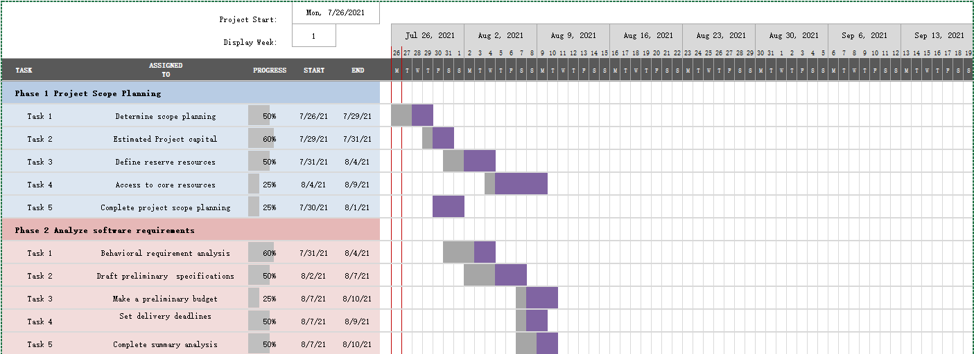 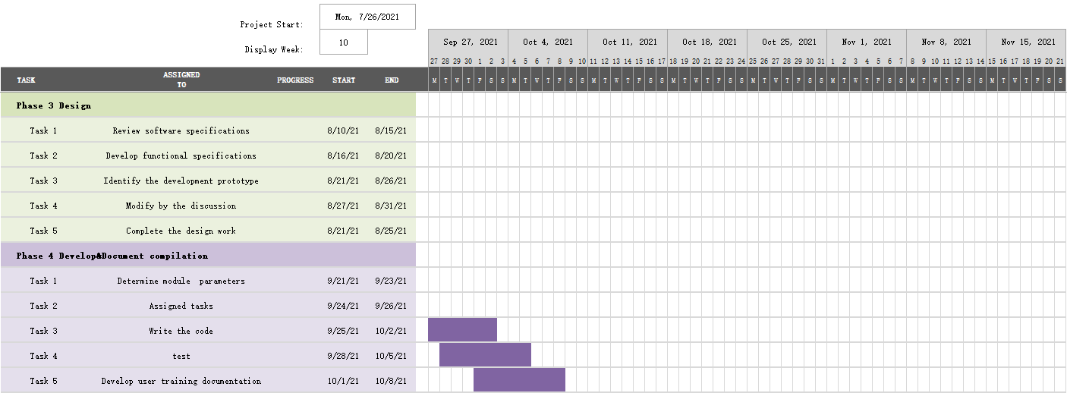

fig1：Gantt chart

Agile product backlog

|  |  |  |  |
| --- | --- | --- | --- |
| Kepper FM Project | | | |
| ID | Story | Estimation | Priority |
| 1 | As a maintenance I want to Handle staff needs | 4 | 8 |
| 2 | As a maintenance I want real-time monitoring | 4 | 7 |
| 3 | As a maintenance I want to deal with the  demand for single | 3 | 6 |
| 4 | As a maintenance I want intelligent diagnosis | 3 | 3 |
| 5 | As a maintenance I want to store data of  which system generated | 4 | 4 |
| 6 | As a staff I want to register | 2 | 1 |
| 7 | As a staff I want to login | 2 | 2 |
| 8 | As a staff I want to use demand for single | 5 | 5 |
| 9 | As a staff I want to use office automation | 5 | 9 |
| 10 | As a staff I'd like to release streaming media release | 6 | 10 |
| total |  | 38 |  |

Table 1：Agile product backlog

Burn down chart

fig 2：Burn down chart

The figure shows the burndown progress of 10 weeks, where the blue represents the actual progress curve, and the orange represents the progress curve under the condition of constant productivity of members. As can be seen from the figure, the curve changed sharply in week 2 and week 9, indicating that our project needs to be adjusted according to the actual situation.

Agile release plan

|  |  |  |  |  |  |
| --- | --- | --- | --- | --- | --- |
| **Week 5** | **week6** | **week 7** | **week8** | **week 9** | **week 10** |
| Release planning | | |  |  |  |
|  |  |  | Load data to coud |  |  |
|  | Prioritize functions |  |  |  |  |
| Define functionality |  |  |  |  |  |
| Create account | |  | Test the project | | |
|  |  |  | Check stuff demands |  |  |
| Coding |  |  | Maintain the website |  |  |
| Develop the website | | | |  | Plan high |
|  |  | safety monitoring |  |  |  |
|  | 1.0  Release |  | 2.0 Release |  | 3.0 Release |

Table 2：Agile release plan

The above table shows the release version of the project. From 1.0 to 2.0, and finally to 3.0, this is a very comprehensive approach. After the details of each small unit are determined, the work can be effectively carried out to ensure the release of the version on time..

2 User stories (write requirements in story forms)

The above use case has a total of two actors involved in the system.The five roles are Kepper FM staff and GoDaddy maintenance staff.

Kepper FM staff: Managers who have accounts on the site.They have access to much of the system and can manage their own content.

GoDaddy Maintenance: Is a maintenance personnel who maintains the website and can handle information about the needs of Kepper FM employees with "request as maintenance personnel.

Figure 2 shows the maintenance functions required by maintenance personnel.Among them, there are mainly intelligent diagnosis, office automation management and processing staff needs.Figure 3 shows all the individual use cases that employees are involved in.In addition to registration and login, there is also the maintenance of streaming media resources.Figure 4 is the largest use case diagram, showing all of the interactions that employees and members have with maintainers.

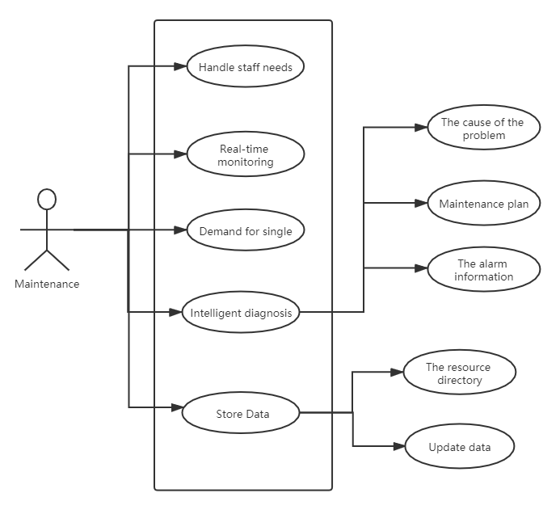

Fig3

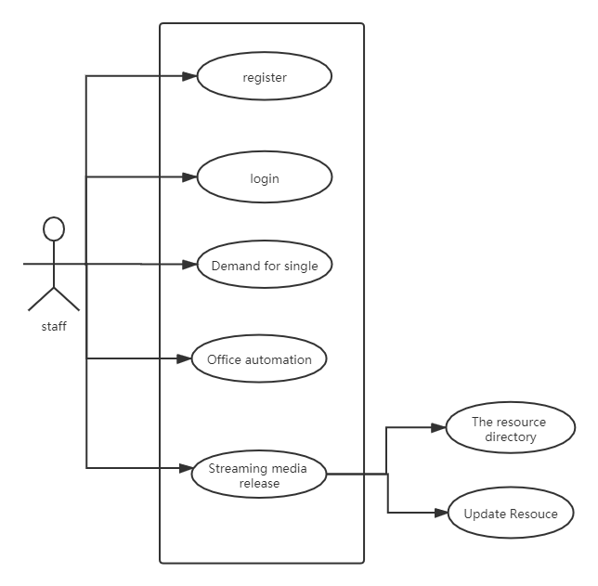

Fig 4

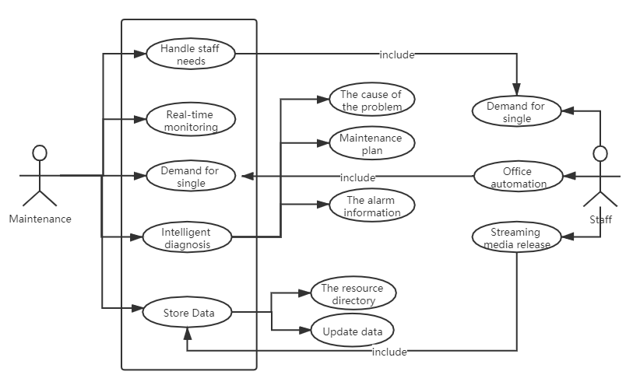

Fig 5

3 Risk estimation on the project

|  |  |  |  |  |  |  |
| --- | --- | --- | --- | --- | --- | --- |
| no | **Risk  categories** | **Risk  description** | **Probability of  occurrence** | **Influence  degree** | **Risk level** | **Response plan** |
| 1 | Market risk | Small product  market | high | middle | middle | Develop products  of the same type |
| 2 | Increase in  competitors | middle | low | low | Communicate the advantages of  the project to the client |
|  |  |  |  |  |  |  |
| 1 | Technical risk | Technical  reserves | middle | middle | middle | Collaboration with research institutions |
|  |  |  |  |  |  |  |
| 1 | Financial risk | Costs are higher than expected | middle | low | low | Improve cost analysis |
| 2 | Critical equipment  missing | low | low | middle | Supplier  substitution |
|  |  |  |  |  | low |  |
| 1 | Management  risk | Project status is  unclear | low | low | low | Enhance communication management |

Table 3: Project risk level management

Identify potential hazards in the project, including inherent, potential or man-made hazards and events caused by equipment, operation, maintenance and other aspects. Based on the integrity of the system, the existing safety level of the system is comprehensively evaluated, and the corresponding safety suggestions and measures are put forward. The following are the criteria for judging the probability of risk occurrence:

**Risk occurrence probability judgment criteria:**

High risk: > 60% chance of risk occurring

Medium risk: 30%~ 60% chance of risk occurring

Low risk: <30% chance of risk occurring.

4 Benefits that the project will bring

The phases of a complete project development include: planning and use-case specification, project structure and risk assessment, business function specification, code implementation, testing, operations manual, and so on. A project requires a large amount of financial resources and manpower. If there is no good risk planning, it will have a great impact on the future progress.

Here's what you learned from the project:

1.Good documentation: This is an important part of the development process, and the lack of documentation can be extremely troublesome for future errors, upgrades, and module reuse. This can result in significant code changes.

2.Code writing habits: helps with code migration and error correction, and also helps with collaboration among technicians.

3.Understanding requirements: Truly understanding the role of another module makes the project more secure and stable.

4. enhance competitiveness.

5.A mobile friendly website will be provided.

Following are the advantages that we received after this project:

1. Learn professional knowledge, enrich ourselves. Know what I need to know about my career.

2. Understand social reality, including interpersonal communication, communication style and related etiquette.

3. Learn teamwork, be good at using the wisdom of others, patiently listen to ea ch member's opinion.

4. Master the way to deal with things, improve their mind and the ability to face the problem

5. The first time to contact customer needs, from the customer's point of view to think about the problem, design a more reasonable software structure.

5 Budget management

Software projects face a dilemma of goals versus schedule and cost. The first step in software estimation is to determine whether project goals are realistic enough to achieve them in a manageable manner. Estimates don't have to be accurate, they have to be useful. Here is the table for budget management:



Table 4: Risk Plan of current project

Software projects can be affected by budgets, and the lack of a budget can lead to high costs. The table above shows the number of hours each person worked and the corresponding cost, which comes to $75,000.

6 Monitoring and reporting

(1) Weekly status reports

|  |  |  |  |
| --- | --- | --- | --- |
| Project name： Kepper FM Project | | | |
| Record no | Weekly status reports _001 | Task stage | Startup phase |
| head | Tsz Kit Choi | writers | Tsz Kit Choi |
| Project schedule | | | |
| |  |  |  |  |  |  | | --- | --- | --- | --- | --- | --- | | **Task name** | **Scheduled completion time** | **Whether delay** | **current progress** | **Those responsible** | **note** | | Scope planning | 2021.7.29 | no | 50% | Tsz Kit Choi |  | | Assess feasibility | 2021.7.29 | no | 50% | Tsz Kit Choi |  | | | | |
| Kepper FM Project of this week's progress: | | | |
| 1. Make a plan to ensure quality and arrange the details of team work .  2. Conduct in-depth research on the application scenarios proposed by the builder ； | | | |
| problems and risks now | | | |
| Project progress is slow | | | |
| Customer needs to cooperate with matters | | | |
| Specific requirements need to be put forward | | | |
| Priorities for next week | | | |
| 1. Identify customer needs 2. Assign people as soon as possible 3. Speed up project schedule | | | |

Table 5: Weekly status report

(2) Project Team status meeting

|  |  |  |  |  |
| --- | --- | --- | --- | --- |
| **no.** | **Problem description** | **Deadline** | **status** | **Resolution of the situation** |
| 1 | Identify appropriate personnel | 2021/7/26 | completed |  |
| 2 | Sort out the corresponding needs for selection | 2021/7/26 | processing |  |
| 3 | Establish analytical application model | 2021/7/31 | processing |  |
| 4 | Conduct in-depth research on application scenarios proposed by customers | 2021/7/31 | processing |  |
| 5 | Develop project schedule | 2021/7/31 | processing | Submit preliminary project inversion schedule |
| 6 | Submit the list of relevant personnel | 2021/7/31 | processing | Submit a preliminary list of personnel |
| 7 | Table the associated data according to the requirements of the application scenario | 2021/7/31 | processing |  |
| 8 | Contact Kepper FM to participate in program development | 2021/7/31 | processing |  |

Table 6: Project Team status meeting

(3) Project Owner status meeting:

|  |  |  |  |
| --- | --- | --- | --- |
| The theme | Kepper FM | | |
| Record number | Project Owner status meeting_001 | | |
| Date | 2021-07-24 | Address | The classroom |
| The host | Kepper FM head | The recorder | Tsz Kit Choi |
| attendees | The customer：Kepper FM stuff  Unit construction：Project team member | | |
| The main purpose of this meeting is to report and discuss the current problems and progress of the project.  Meeting content and decision：  **A.Content of contractor's report**：  1.According to the revised plan plan requested by the team meeting, the plan work arrangement plan was deeply optimized.  2. Adjust personnel and optimize personnel structure.  **B.The client summarizes the contents and requirements for the next phase of work：**  1.Demonstrate and screen the landscape schemes required for the construction of the platform, and submit the mature schemes that meet the construction requirements and expectations of the project to the customer for discussion, selection and confirmation.  2.The client contractor determines the detailed list of on-site personnel and proceeds with the project. | | | |

Table 7: Project Owner status meeting

7 Quality assurance plan

Roles for Responsibilities

|  |  |  |
| --- | --- | --- |
| Name | Role | Responsibility |
| Kepper_stuff | Duty | Quality duty |
| Member1 | Project Head | Quality Mentoring, coaching and testing |
| Member2 | Software Developer and Tester | Quality for development and testing |
| Member3 | Document writer | Quality edit |

Table 7: Quality assurance plan

Quality Metrics

|  |  |  |  |
| --- | --- | --- | --- |
| Metric | Standard | Method | Quality Criteria |
| Cyclomatic Complexity | The site should be  The website needs to be simple to operate. | Audit | Based on the rationality of mathematical model design, it is necessary to analyze the time and space complexity of an algorithm to determine the feasibility of the algorithm. |
| Portability | Websites can be reused | Audit | Software can be compatible to a platform and can be reused. |
| Maintainability | Websites can be easily maintained | Audit | Refers to the ability of a software product to be modified. Modifications include modifications, optimizations, and descriptions of functional specification changes. |
| Functionality | Websites can clearly reflect the needs of users. | Test | The ability of software to meet users' explicit and implicit requirements under specified conditions. |
| Reliability | Websites can respond to questions. | Test | To reduce software defects or to avoid exposing internal design details. |
| Usability | The website is user-friendly. | Audit and test | The ability of a software product to be used, understood and learned under specified conditions. |
| Efficiency | The site has good performance. | Future feature adding and modifiy. | The ability of a software product to provide appropriate performance relative to the amount of all resources under specified conditions. |
| Security | System must be safe. | Test | Security requires consideration of user privacy, whether there are vulnerabilities, and whether the running process will blink. |
| User Interface | The website should  have consistent design. | Audit and test | Provide a set of standard interfaces for the basic data format and the corresponding business processes. |

Table 8: Quality Metrics

Link to Project Management Tool: <https://keppelfm.atlassian.net/jira/software/projects/C1/boards/1/roadmap>

Link to Code repository:

https://github.com/Shahiduddin/Keppel-FM